Faculty of Engineering and Technology

Department of Electronics and Communication Engineering

Jain Global Campus, Kanakapura Taluk - 562112  
Ramanagara District, Karnataka, India

**2017-2021**

A Project Report on

“IoT Based Smart Shopping Cart”

Submitted in partial fulfilment for the award of the degree of

Bachelor of Technology

in

ELECTRONICS AND COMMUNICATION ENGINEERING

Submitted by

Akhilesh Shinde

17BTLEC002

Vijay Kumar Rayanagoudra

17BTLEC008

Anish Kumar Singh

17BTREC017

Rahul Rao Shinde K

17BTLEC012

Under the guidance of

**Prof. Basavraj.H**

Assistant /Associate Professor / Professor

Department of Electronics and Communication Engineering

Faculty of Engineering & Technology

JAIN (DEEMED-TO-BE UNIVERSITY)

Faculty of Engineering & Technology

Department of Electronics & Communication Engineering

Jain Global campus

Kanakapura Taluk - 562112  
Ramanagara District

Karnataka, India

CERTIFICATE

This is to certify that the project work titled **“IoT BASED SMART SHOPPING CART”** is carried out by **AKHILESH SHINDHE (17BTLEC002), VIJAYKUMAR S R (17BTLEC008),ANISHKUMAR SINGH (17BTREC017),** **RAHUL RAO SHINDE (17BTLEC012),** are bonafide students of Bachelor of Technology at the Faculty of Engineering & Technology, JAIN DEEMED-TO-BE UNIVERSITY, Bengaluru in partial fulfillment for the award of degree in Bachelor of Technology in Electronics and Communication Engineering, during the year **2020‑2021**.

|  |  |  |
| --- | --- | --- |
| **Guide Name** | **Dr. R. Sukumar** | **Dr. Hariprasad S.A** |
| Assistant/Associate Professor  Dept. of ECE,  Faculty of Engineering & Technology,  JAIN DEEMED-TO-BE UNIVERSITY  Date: | Head of the Department, Electronics and Communication,  Faculty of Engineering & Technology,  JAIN DEEMED-TO-BE UNIVERSITY  Date: | Director,  Faculty of Engineering & Technology,  JAIN DEEMED-TO-BE UNIVERSITY  Date: |

Name of the Examiner Signature of Examiner

1.

2.

DECLARATION

We, **Akhilesh Shinde 17BTLEC002, Vijaykumar S Rayanagoudra 17BTLEC008, Anish Kumar singh 17BTREC017, Rahul Rao Shinde K 17BTLEC012,** are student’s of eighth semester B.Tech in **Electronics and Communication Engineering**, at Faculty of Engineering & Technology, **JAIN DEEMED-TO-BE UNIVERSITY**, hereby declare that the project titled **“IoT Based Smart Shopping Cart”** has been carried out by us and submitted in partial fulfilment for the award of degree in **Bachelor of Technology in Electronics and Communication Engineering** during the academic year **2020-2021**. Further, the matter presented in the project has not been submitted previously by anybody for the award of any degree or any diploma to any other University, to the best of our knowledge and faith.

|  |  |  |  |  |  |  |  |  |  |  |  |  |  |
| --- | --- | --- | --- | --- | --- | --- | --- | --- | --- | --- | --- | --- | --- |
| |  |  | | --- | --- | |  | Signature | | Anish Kumar Singh (17BTREC017) |  | | Akhilesh Shinde(17BTLEC002) |  | | Vijaykumar S Rayanagoudra  (17BTLEC008) |  | | Rahul Rao Shinde K  (17BTLEC012) |  | | Place : Bengaluru  Date : |  | |  |
|  |  |

**ACKNOWLEDGEMENT**

*It is a great pleasure for us to acknowledge the assistance and support of a large number of individuals who have been responsible for the successful completion of this project work.*

*First, we take this opportunity to express our sincere gratitude to* **Faculty of Engineering & Technology,JAIN DEEMED-TO-BE UNIVERSITY** *for providing us with a great opportunity to pursue our Bachelor’s Degree in this institution.*

*In particular we would like to thank* ***Dr. Hariprasad S.A****,* ***Director****,* **Faculty of Engineering & Technology**,**JAIN DEEMED-TO-BE UNIVERSITY***for his constant encouragement and expert advice.*

*It is a matter of immense pleasure to express our sincere thanks to* ***Dr. R. Sukumar****,* **Head of the department**, **Electronics and communication Engineering**, **JAIN DEEMED-TO-BE UNIVERSITY*,*** *for providing right academic guidance that made our task possible.*

*We would like to thank our guide* ***Prof. Basavraj. H*** *, Associate /* ***Assistant Professor****,* **Dept. of Electronics and Communication Engineering**, **JAIN DEEMED-TO-BE UNIVERSITY***, for sparing his/her valuable time to extend help in every step of our project work, which paved the way for smooth progress and fruitful culmination of the project.*

*We would like to thank our Project Coordinator* ***Mr. Sunil M P*** *and all the staff members of Electronics and Communication for their support.*

*We are also grateful to our family and friends who provided us with every requirement throughout the course.*

*We would like to thank one and all who directly or indirectly helped us in completing the Project work successfully.*

*Signature of Students*

|  |  |
| --- | --- |
|  |  |
|  |  |
|  |  |
|  |  |

ABSTRACT

Shopping has become an integral part of today’s society. We can see a huge rush at the mall and supermarkets during weekends, holidays and sales. A queue-based billing system prevails in the existent scenario in most of the developing countries and few developed countries, demanding an intermediary labour intensive or conveyor belt-based billing of products. One of the measures adopted includes RFID tagging of products. However, high cost of both tag and reader makes item-level RFID tagging impractical except for high-value products .Hence a proposal was to come up with and advancement that utilizes the barcode scanners and other related resources such as IOT(internet of things) based shopping carts. The proposed IOT based smart shopping cart which comes together with a barcode scanner and a screen display is designed which would help the customer to pay for their goods in the mall and supermarket without being served by a sales associate. Every product in the supermarket will have a barcode the customer will pick the product scan the barcode with the help of barcode scanner. After scanning the barcode, the concept is designed into a smaller version of the automated self-checkout system on a shopping cart with a user interface screen which allows customers to make payment for items scanned and placed in the cart before leaving the entrance of the store. This is to release pressure during peak hours. The smart cart comes with all the services including scanning an item to check for price and details, also there are other additional features that will be included in the design such as locating an item in the store by typing in the item’s name in the search field on the user interface screen which will automatically show the item’s location and also we can set the budget. The details and the price of the product will be displayed on the touch screen display along with the total bill of the items purchased. This system would also be beneficial for the customer with a certain budget limit and saves long waiting time at the billing counter. Besides, the design also entails a security feedback unit which scrutinizes all the products in the cart. Based on that, discrepancies and falsehood can be alarmed, locking the cart at the very instant. At the database end, flexibility is provided as per the wish of the owner/management unit of the store. It facilitates in monitoring the consumer behaviour, recognizing trends among various brands.

**TABLE OF CONTENTS**

|  |  |
| --- | --- |
| List of Figures | v |
| List of Tables | vi |
| Nomenclature used | vii |
| **Chapter 1** | **01** |
| 1. **Introduction** | **01** |
| 1. Literature Survey | 01 |
| 1. Limitations of the Current Work | 02 |
| 1. Problem Definition | 04 |
| 1. Objectives | 05 |
| 1. Methodology | 06 |
| 1. Hardware and Software tools used | 07 |
|  |  |
| **Chapter 2** | 09 |
| 1. **Basic Theory** | 09 |
|  |  |
| **Chapter 3** | **05** |
| 1. **Tool Description** | **05** |
|  |  |
| **Chapter 4** | **08** |
| 1. **Implementation** | **08** |
| 1. Hardware Design and Implementation | 08 |
|  | 09 |
|  | 10 |
|  | 11 |
|  | 11 |
|  | 11 |
| 1. Software algorithm | 11 |
|  |  |
| **Chapter 5** | **39** |
| 1. **Results And Discussion** | **39** |
|  |  |
| **Conclusions And Future Scope** | **43** |
|  |  |
| **References** | viii |
|  |  |
| Appendices |  |
| Appendix – I | **ix** |
| Appendix – II | **x** |
| **Details of Paper Publication(Along with Paper)** | **xi** |
| **Information Regarding Students** | **xii** |
| **Batch Photograph Along With Guide** | **xiii** |
|  |  |

**Chapter 1**

**Introduction**

Commonly as in vogue of now, shopping has become an integral part of today’s society. We can see a huge rush at the mall and supermarkets during weekends, holidays and sales. A major concern for the customer at the mall and supermarket occur when there is a long waiting queue at the billing counter.The customer tends to leave the queue rather than standing for hours at the billing counter this turns out to be a trouble for the mall and supermarket owner.A queue-based billing system prevails in the existent scenario in most of the developing countries and few developed countries,demanding an intermediary labor intensive or conveyor belt-based billing of products. One of the measures adopted includes RFID tagging of products.However, high cost of both tag and reader makes item-level RFID tagging impractical except for high-value products . A simpler approach would be to embed RFID devices in consumers’ shopper cards to identify them such retail system essentially involves tradeoffs between enhanced functionality and privacy protection. Instead of adapting to these, the proposal was to come up with and advancement that utilizes the barcode scanners and other related resources such as shopping carts.

The Internet of Things (IoT) by definition refers to a ever-growing network of physical objects including computing devices, mechanical and digital machines,animals or people or objects provided with unique identifiers having ability to transfer data over the same network without requiring human or computer inter-action. The proposed IoT based smart shopping cart which comes together with a barcode scanner and a screen display is designed which would help the customer to pay for their goods in the mall and supermarket without being served by a sales associate. Every product in the supermarket will have a barcode the customer will pick the product scan the barcode with the help of barcode scanner. After scanning the barcode, the concept is designed into a smaller version of the automated self-checkout system on a shopping cart with a user interface screen which allows customers to make payment for items scanned and placed in the cart before leaving the entrance of the store. This is to release pressure during peak hours. The smart cart comes with all the services including scanning an item to check for price and details, also there are other additional features that will be included in the design such as locating an item in the store by typing in the item’s name in the search field on the user interface screen which will automatically show the item’s location and also we can set the budget. The details and the price of the product will be displayed on the touch screen display along with the total bill of the items purchased. This system would also be beneficial for the customer with a certain budget limit and saves long waiting time at the billing counter

Besides, the design also entails a security feedback unit which scrutinizes all the products in the cart. Based on that, discrepancies and falsehood can be alarmed, locking the cart at the very instant. At the database end, flexibility is provided as per the wish of the owner/management unit of the store. It facilitates in monitoring the consumer behavior, recognizing trends among various brands. The owner can supervise the functioning of the store at ease from any corner of the world.Further expansions based on the owner’s desire can be implemented on the design as well.

* 1. Literature Survey

1. Chandrasekar et al. [1] the authors have presented their idea in which each commodity in a mall will be attached with an RFID tag and each trolley will be attached with an RFID reader which would be working on the ZigBee wireless module. A centralized system is present for any help and queries and for the billing transaction of the products by the customers. Even the exit gates of the mall are laced up with the RFID readers for detecting any theft. However, there is no user interface and hence it is not a user-friendly system

Vrinda et al.[2] have featured a cart equipped with an RFID reader, a ZigBee transceiver and an LCD display. This smart shopping cart keeps an account of the bill made by keeping running total of the purchases. An LCD screen shows the total bill of the items present in the cart. However, this system does not have a user interface and ZigBee is used instead of a Wi-Fi module. This work, however, lacks built-in security checks for discrepancies.

Anjali Verma et al. [3] proposed RFID based Smart Multitasking Shopping Trolley System. The proposed system evaluates many strategies to assist shopper to minimize the overall shopping time required in the mall. This system also provides real-time updates based on the inventory to the store management.

1. S.Rajagopal et al. [4] proposed a Smart Intelligent System for Shopping and Billing. In this paper smart shopping cart equipped with RFID tags is considered, to verify the purchase details. Centralized billing system to automatically bill the shopper for the purchases.

Ankush Yewatkar et al. [5] proposed Smart Cart with Automatic Billing, Product Information, Product recommendation Using RFID & Zigbee with Anti- Theft system This smart shopping cart system keeps the track of all purchased products using RFID & Zigbee. For final billing, online transactions are recommended. One of the important feature this system introduced for anti-theft by attaching an RFID reader at the exit door.

Budic et al. [6]proposed a system of Cash register lines optimization system using RFID technology and developed a system for shopping using RFID. The RFID is employed for scanning products and the information is stored in the database which could be paid online or in a central bill. It also uses web application to maintain entire shopping details. It requires maintenance of a web application server. No necessary steps have been taken for the products that are accidentally dropped into the trolley by the customer.

V. N. Prithvish et al [7] the authors have presented their idea where they have implemented concept of IoT with a conventional barcode as the tagging identity and the current bill will be displayed on their smart devices keeping them well informed about their purchases and aiding them to take further purchase decisions. The smart cart’s payment system is being implemented by using technologies such as RFID or NFC connected to credit/debit card swiping machines present at remote locations of the store .However the product imaging algorithm had to be applied only in case of a constant light luminosity in the surrounding and limitations include aberrant behavior of algorithm in dim light environment and minimal investment in the production of customized central hardware resulting in an option a bit extravagant compared to the other options such as smart phone app to scan barcodes and do all the processing.

* 1. Limitations of the Current Work

The implementation in previously proposed prototypes were expensive to implement on large scale .Henceforth it was difficult for small scale vendors to adopt it and in most of the scenarios it was difficult to stick RFID tags to some products due to their different surfaces and shapes and attaching it to each and every product involves a high maintenance cost and investment and most of the RFID tags can be easily damaged.There was synchronization latency between the scanning of the products and product imaging Investment in the production of customized hardware resulting is not economical compared to proposed prototype.The billing of the products was implemented through by using technologies such as RFID which is connected to credit/debit card swiping machines present at remote locations of the store due to which it resulted in long waiting wait of customer.

* 1. Problem Definition

Now a days purchasing and shopping at supermarkets is becoming a daily activity in metro cities. We can see huge rush at supermarkets on holidays and weekendsand has resulted in large crowds at supermarkets which have to lead to long lines at the billing counter.Because the cashier has to scan every product item and then enter it into the billing record.The prevailing billing system is a bit time consuming and the ongoing covid19 crisis demands from everyone to make safety and hygiene standards the top priority.the proposed project will help in reducing customer contact with anything that someone else might have touched or had contact with it. The current system involves a large amount of manual handling on the part of the customer which is useful for the management of the shop but does nothing for the customer. It does not provide a feasible solution to reduce the time spent by the customer in the store, mainly while standing in line for billing and payment. This is because of a lack of alternative mode of payments. The main drawback is the lack of satisfaction and ease of use on the part of the customer.

* 1. Objectives
* The main objective of this project is to reduce and eliminate time taken in billing counter in super markets
* And to implement Contactless Shopping in concerns with safety and people’s health and safety to limit physical contact in supermarkets
* By designing an Smart Shopping Cart which allows users to self-checkout and increase productivity time

* 1. Methodology

This IoT based smart shopping cart makes note of all the scanned commodities of the particular trolley with allotment number and is linked with the supermarket's backend database which contains details of the product such as cost price, available stock, the quantity of the product and location of the product. The IoT based smart shopping cart system is linked with various devices such as barcode scanner, NodeMCU, LCD display, loadcell, buzzer, database.

It provides the facility to the customer to self-scan the products which the customer wants to purchase. After purchasing or self-scanning the product if the customer wants to make changes in product detail such as add or remove he can easily update the products detail by using the touch screen where the add, remove, update, delete keys are provided. As we have provided the self-scan facility to the user and the wireless smart devices which make of all the scanned products and connected with supermarket database. At the time of purchasing the products, the customer is aware of the total bill. Product imaging and load cells have been deployed to handle with dishonest customers in the absence of manual security. Thereby significantly reducing turnaround time and transmitted to the Super Market’s Billing program. By this mechanism, the time consuming work of scanning and billing every single product at the cash counter can be avoided.Recommendation engines have been deployed in the app to recommend products to the user based upon their present and past purchasing behavior and to assist the user to the location of their preferred products.

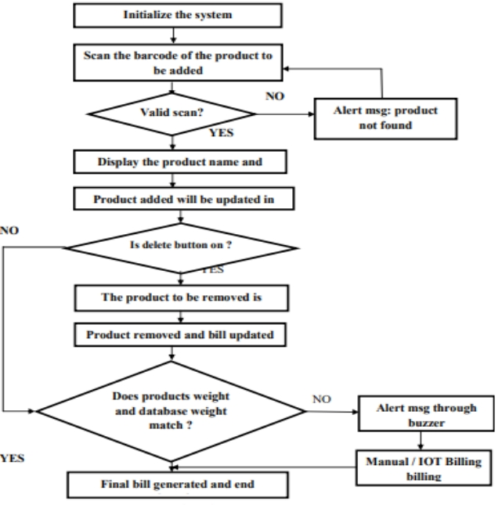

Fig1.1,Flow Chart

* 1. Hardware and Software tools used

**Hardware Tools:-**

|  |  |  |  |
| --- | --- | --- | --- |
| Sl.No | Component Name | Specification | Quantity |
| 1 | Node MCU | ESP8266 | 1 |
| 2 | Load Cell | CZL601 (5–60 kg) | 1 |
| 3 | Camera | ESP32(OV2640) | 1 |
| 4 | Lipo Rechargable Battery | 3.7V,400mAH | 1 |
| 5 | Barcode reader with camera | Wireless Smart device | 1 |
| 6 | Load Cell Amplifier Module | HX711 | 1 |

**Software Tools:-**

1. Ardiuno Ide
2. MySQL
3. MIT App Inventor
4. Proteus Professional
5. Microsoft Visual Studio

Chapter 2

2.BASIC Theory

The entire system is composed of two subsystems:

I.The smart cart database system

II.The smart cart feedback system

Figure 2.1 shows the design of the smart cart database system, which utilizes barcode scanner, the sensing element of the subsystem, that takes barcodes of different commodities as input to the system, checks in for the commodities into the database, further adding/removing it to the cart system. Following each scan, the data are directed to the cloud, revising the inventory. This smart cart will keep updating the restocking process so that no product is off the shelf. It will also lead customers to the location of their preferred products and assist them on the basis of their earlier purchases. The same smart cart will keep customers informed about their billing amount to aid them to make further purchase decisions. A customer shall contain his/her own login ID and password. The smart cart not only eases the work at the store but also adds technological aspects to a store.

Figure 2.2 shows the block diagram of the smart cart feedback subsystem which is a combination of both weight sensing unit and product imaging unit particularly added to make a flawless exemplary system. The customer may face contrarieties such as product not being scanned properly and added to the cart, product being scanned but not added to the cart, products with same weight but different price, and product description being added to the cart. Additionally, there may be instances where the customer attempts scanning of a single product but adds several products into the cart or attempts where high-priced commodity is placed into the cart, scanning the barcode of a low-priced commodity. Thus, feedback system ensures the error-free and theft-free supermarket in absence of manual security.

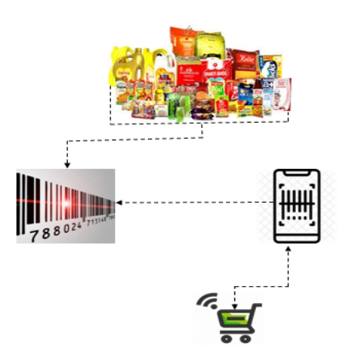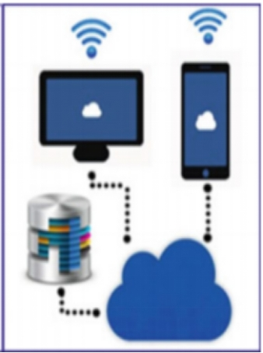

Fig. 2.1 Design for the smart cart database system

C:\Users\Meera\AppData\Local\Temp\ksohtml9888\wps4.pngC:\Users\Meera\AppData\Local\Temp\ksohtml9888\wps5.png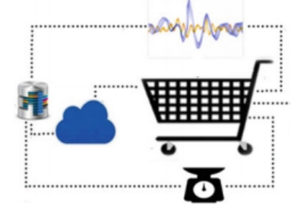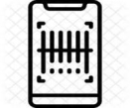

Fig. 2.2 Block diagram of the smart cart feedback system

Chapter 3

3. Tool Description

1. **NODE MCU ESP8266**: A low cost and highly integrated solution to connect wirelessly, this microcontroller is powered by a 32-bit Tensilica Microprocessor, which makes it possible for it to consume minimum battery resources. The WiFi stack, as well as the Real Time Operating System, allow the user to use 80% of the power for program processing and application development. It is a highly durable, compact and is able to operate for long hours on a single battery, making it suitable for a portable device like a smart supermarket trolley.

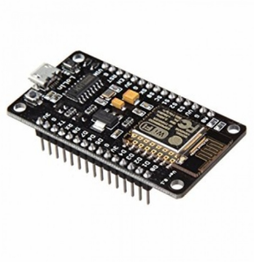

Fig 3.1 NODE MCU-ESP8266 WIFI Development Board

1. **Load cell**:- A load cell is a transducer which is used to create an electrical signal whose magnitude is directly proportional to the force being measured. The load cell is the heart of any weighing machine or electric scales. This type of transducer is highly accurate which provides the user with the required information. Strain gauge load cells work on the principle that the strain gauge (a planar resistor) deforms when the material of the load cells deforms appropriately. Deformation of the strain gauge changes its electrical resistance, by an amount that is proportional to the strain. The change in resistance of the strain gauge provides an electrical value change that is calibrated to the load placed on the load cell.

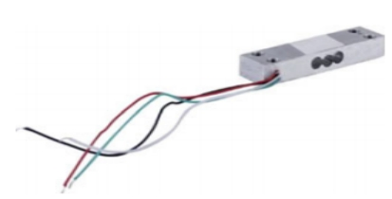

Fig 3.2 Load cell CZL601

1. **Camera**:- ESP32-CAM is a development board module with a size of 27×40mm. It can be integrated into a camera system with an ESP32 module and camera. ESP32-CAM can be widely used in various IoT applications. It is suitable for home smart devices, industrial wireless control, wireless monitoring, QR wireless identification, wireless positioning system signals and other IoT applications. It is an ideal solution for IoT applications.

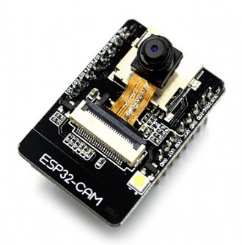

Fig 3.3 ESP32 CAM

1. **Lipo Rechargable Battery** :-A lithium polymer battery, or more correctly lithium-ion polymer battery. s a [rechargeable battery](https://en.wikipedia.org/wiki/Rechargeable_battery) of [lithium-ion](https://en.wikipedia.org/wiki/Lithium-ion_battery) technology using a [polymer](https://en.wikipedia.org/wiki/Polymer) [electrolyte](https://en.wikipedia.org/wiki/Electrolyte) instead of a liquid electrolyte. High conductivity semisolid polymers form this electrolyte. These batteries provide higher [specific energy](https://en.wikipedia.org/wiki/Specific_energy) than other lithium battery types and are used in applications where [weight](https://en.wikipedia.org/wiki/Weight) is a critical feature, such as [mobile devices](https://en.wikipedia.org/wiki/Mobile_device), [radio-controlled aircraft](https://en.wikipedia.org/wiki/Radio-controlled_aircraft) and some [electric vehicles](https://en.wikipedia.org/wiki/Electric_vehicle).

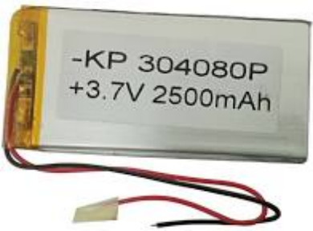

Fig 3.4 Lipo Rechargable Battery

1. **Barcode Reader with Camera**:--Barcode reader with camera A barcode reader is an electronic device that can read and output printed barcodes to a computer. It consists of a light source, a lens and a light sensor translating optical impulses into electrical ones. Additionally, nearly all barcode readers contain decoder circuitry analysing the barcode’s image data provided by the sensor and sending the barcode’s content to the scanner’s output port. A standard barcode scanner shines LED or laser light across a barcode, and the beam is reflected back into a light detecting photoelectric cell. The resulting pattern of impulses corresponding to the black and white stripes is converted into respective decimal numbers. After acquiring an image, a digital camera sends it to the software. Here, a program pre-processes the image to prepare it for further analysis. This stage usually includes converting to grayscale and applying various filters to reduce image noise and enhance barcode edges. After that, a binary operation is performed, which means that only black and white pixels remain in the image. The decoding process consists of two major steps: the location and decoding of the barcode as such.

1. **Load Cell Amplifier Module**:-- HX711 load cell amplifier module uses 24 high-precision A/D converter chip hx711, is designed for high-precision electronic scale and design, with two analog input channels, the internal programmable gain amplify integrated multiplier 128. The HX711 uses a two-wire interface (clock and data) for communication. The input circuit can be configured to provide a bridge type pressure bridge (such as pressure, weighing sensor mode) which is of high precision.

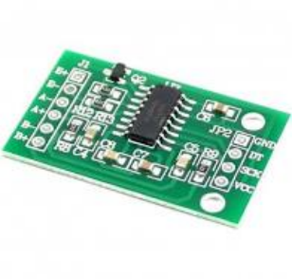

FIG 8:- HX711 Weighing Module

1. **Ardiuno Ide**:- The arduino integrated development environment is a cross-platfrom application that is written in functions from c and c++.it is used to write and upload programs to arduino compatible boards,but also with help of third party cores,others vendor develpment boards.

1. **MySQL** :- A [relational database](https://en.wikipedia.org/wiki/Relational_database) organizes data into one or more data tables in which data types may be related to each other these relations help structure the data. SQL is a language programmers use to create, modify and extract data from the relational database, as well as control user access to the database. In addition to relational databases and SQL, an RDBMS like MySQL works wit an [operating system](https://en.wikipedia.org/wiki/Operating_system) to implement a relational database in a computer's storage system, manages users, allows for network access and facilitates testing database integrity and creation of backups.

1. **MIT App Inventor** :- MIT App Inventor is a web application integrated development environment originally provided by Google, and now maintained by the Massachusetts Institute of Technology (MIT). It allows newcomers to [computer programming](https://en.wikipedia.org/wiki/Computer_programming) to create application software(apps) for two operating systems (OS): [Android](https://en.wikipedia.org/wiki/Android_(operating_system)), and [iOS](https://en.wikipedia.org/wiki/IOS)

1. **Proteus Professional** :- Proteus is a Virtual System Modelling and circuit simulation application. The suite combines mixed mode SPICE circuit simulation, animated components and microprocessor models to facilitate co-simulation of complete microcontroller based designs. Proteus also has the ability to simulate the interaction between software running on a microcontroller and any analog or digital electronics connected to it. It simulates Input / Output ports, interrupts, timers, USARTs and all other peripherals present on each supported processor.

1. **Microsoft Visual Studio**:- Microsoft Visual Studio is an [integrated development environment](https://en.wikipedia.org/wiki/Integrated_development_environment) (IDE) from [Microsoft](https://en.wikipedia.org/wiki/Microsoft). It is used to develop [computer programs](https://en.wikipedia.org/wiki/Computer_program), as well as [websites](https://en.wikipedia.org/wiki/Web_site), [web apps](https://en.wikipedia.org/wiki/Web_app), [web services](https://en.wikipedia.org/wiki/Web_service) and [mobile apps](https://en.wikipedia.org/wiki/Mobile_app). Visual Studio uses Microsoft software development platforms such as [Windows API](https://en.wikipedia.org/wiki/Windows_API), [Windows Forms](https://en.wikipedia.org/wiki/Windows_Forms), [Windows Presentation Foundation](https://en.wikipedia.org/wiki/Windows_Presentation_Foundation) [Windows Store](https://en.wikipedia.org/wiki/Windows_Store) and [Microsoft Silverlight](https://en.wikipedia.org/wiki/Microsoft_Silverlight). It can produce both [native code](https://en.wikipedia.org/wiki/Machine_code) and [managed code](https://en.wikipedia.org/wiki/Managed_code). Visual Studio includes a [code editor](https://en.wikipedia.org/wiki/Code_editor) supporting [IntelliSense](https://en.wikipedia.org/wiki/IntelliSense) as well as [code refactoring](https://en.wikipedia.org/wiki/Code_refactoring). The integrated debugger works both as a source-level debugger and a machine-level debugger. Other built-in tools include a [code profiler](https://en.wikipedia.org/wiki/Profiling_(computer_programming)), designer for building [GUI](https://en.wikipedia.org/wiki/GUI) applications, [web designer](https://en.wikipedia.org/wiki/Web_designer), [class](https://en.wikipedia.org/wiki/Class_(computing)) designer, and [database schema](https://en.wikipedia.org/wiki/Database_schema) designer. It accepts plug-ins that expand the functionality at almost every level—including adding support for [source control](https://en.wikipedia.org/wiki/Source_control) systems and adding new toolsets like editors and visual designers for [domain-specific languages](https://en.wikipedia.org/wiki/Domain-specific_language) or toolsets for other aspects of the [software development lifecycle](https://en.wikipedia.org/wiki/Software_development_lifecycle) (like the [Azure DevOps](https://en.wikipedia.org/wiki/Azure_DevOps_Server) client.

12. **Product Imaging**:- Product imaging takes a real-time feed of the top layer of the smart cart all the time and cross verifies the products visible with the scanned products. In case if any additional item comes into picture which has not been scanned previously, the cart is locked and is not functional to the customer. Also, the owner is informed about the same. This is achieved by means of scale invariant feature transform (ORB) algorithm which acts as a product tracking mechanism for the cart.

CHAPTER 4

4.1 HARDAWARE DESIGN AND IMPLEMENTATION

**Load Cell and HX711 Connections:-**

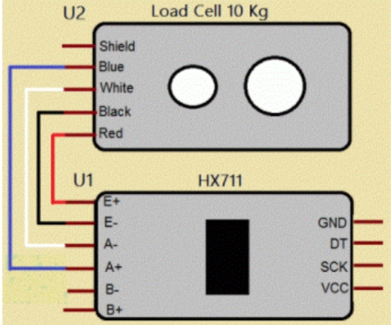

Fig 4.1:Load cell and HX711 Connections

RED wire is connected to E+

BLACK wire is connected to E-

WHITE wire is connected to A-

BLUE wire is connected to A+

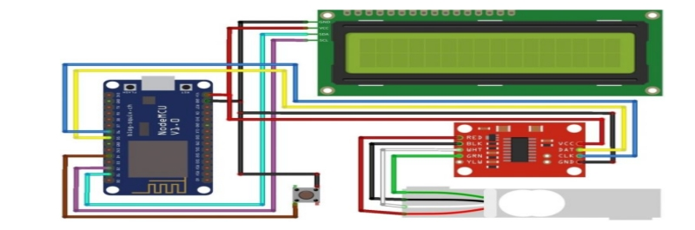

Fig 4.2 circuit diagram for interfacing 40KG Load Cell and HX711 Module with NodeMCU ESP8266 12E Board

The connection between Load Cell & HX711 has been explained above. Connect the DT & SCK Pins of Load Cell to ESP8266 D5 & D6 Pins respectively. We have used a push-button tact switch to reset the weight to zero. Push-button Switch is a connected digital pin D4 of ESP8266. I used a 16X2 I2C LCD Display to minimize the connection. So, connect the SDA & SCL pin of I2C LCD Display to D2 & D1 of Nodemcu respectively.

**4.2 Software algorithm**

**Mobile App Design:-** 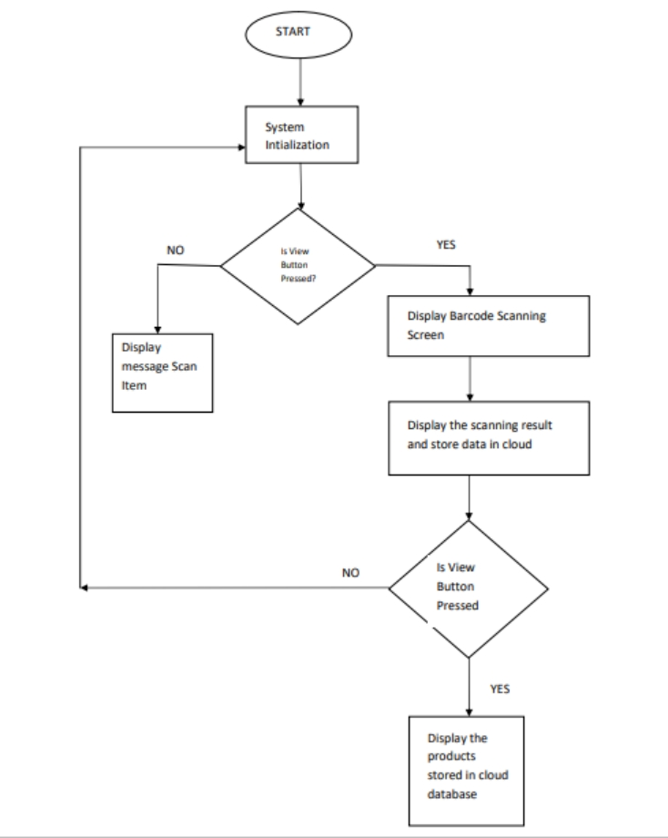

Fig 4.2.1 Flow chart of working of App

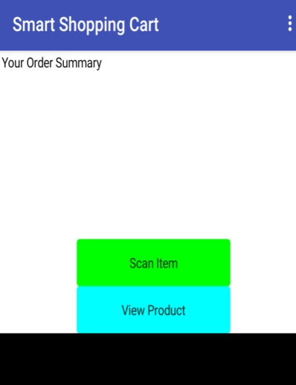

Fig 4.2.2 Home page of the app

Product Imaging Simulation Results using ORB Algorithm:-

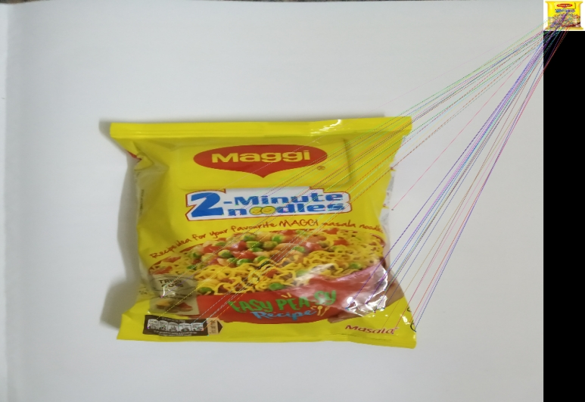

Fig13:- ORB Algorithm Implementation result

Chapter 5

Results And Discussion

MYSQL provides a facility to store data upto a ceratin extent.If one needs facility on the cloud and needs to analyze data further ,advanced data analytics siftware can be used.The application developed for the smart shopping cart will facilitates the owner showing him the daily stock,alarming him when a product is off shelf and needs immediate restocking and it also provides cutomers to scan the barcodes of their desired product and also view the products which they purchased .Product Imaging using ORB algorithm has been implemented to eliminate the thefts and to minimize the losses that occurred to the owner due to the theft activities.

The application developed for the IoT based smart shoppping cart will eliminate the cost of deploying contemporary barcode scanners and the cost incurred for its maintenance and as well as the investment in customized central hardware.The synchronization latency ,royalty fees,less accuracy occurred due to the SIFT algorithm has been improved with the implementation ORB algorithm which yields better results compared to the previous algorithm.

**CONCLUSIONS AND FUTURESCOPE**

In this proposed system,the successful use of the NodeMCU system for the Iot based smart shopping cart has been explained.The drawbacks addressed in previous smart cart applications has been overcome in this application .Project implementation will help people who are shopping in the supermarkets and eliminate standing in a long queue for final billing.The implementation is easy and very economical and will reduce the time required at the billing counter .In our proposed project,we designed IoT based smart shopping cart for the billing system which can be used in any supermarket and by any person easily and act as a self-checkout system providing users with the flexibility to make transacctions from it within the retail store.It is designed to be highly efficient and fully synchronized with the retailer’s current system.The futurescope includes adding more computation at the cloud end.Implementation such a system in retail shall bring down labor dependency,easy management at the owner’s end and in turn will improve the pre and post-shopping experience.

**REFERENCES**

1. Budic D, Martinovic Z, Simunic D, Cash register lines optimization system using RFID technology, IEEE Explore, 2014
2. V. N. Prithvish, Shraddha Agrawal and John Sahaya Rani Alex An IoT-Based Smart Shopping Cart Using the Contemporary Barcode Scanner
3. Chandrasekar P, Sangeetha T (2014) Smart shopping cart with automatic billing system through RFID and ZigBee. IEEE. ISBN: 978-1-4799-3834-6/14
4. Anjali Verma, Namit Gupta. RFID based Smart Multitasking Shopping Trolley System. International Journal for Scientific Research & Development, Vol. 3, Issue 06, 2015, 1389-1392.
5. G.S.Rajagopal, Mr.S.Grout, Prof. M.Janarthanan. Smart Intelligent System for Shopping and Billing. International Journal of Advanced Research Trends in Engineering and Technology, Vol. 3, Issue 19, April 2016, 339-343.
6. Ankush Yewatkar, Faiz Inamdar, Raj Singh, Ayushya, Amol Bandale. Smart Cart with Automatic Billing, Product Information, Product Recommendation Using RFID & Zigbee with Anti-Theft. International Conference on Communication, Computing and Virtualization, 2016, 793 - 800.

**Appendix - I**

**Source Code**

#Algorithm

#Take the query image and convert it to grayscale.

#Now Initialize the ORB detector and detect the keypoints in query image and scene.

#Compute the descriptors belonging to both the images.

#Match the keypoints using Brute Force Matcher.

#Show the matched images.

import numpy as np

import cv2

from google.colab.patches import cv2_imshow

# Read the query image as query_img

# and traing image This query image

# is what you need to find in train image

# Save it in the same directory # with the name image.jpg

query_img=cv2.imread('/content/drive/MyDrive/Images_for_ORB/query_img_bw.jpg')

train_img=cv2.imread('/content/drive/MyDrive/Images_for_ORB/train_image_bw.jpg')

# Convert it to grayscale

query_img_bw = cv2.cvtColor(query_img,cv2.COLOR_BGR2GRAY)

train_img_bw = cv2.cvtColor(train_img, cv2.COLOR_BGR2GRAY)

# Initialize the ORB detector algorithm

orb = cv2.ORB_create()

# Now detect the keypoints and compute

# the descriptors for the query image

# and train image

queryKeypoints, queryDescriptors=orb.detectAndCompute(query_img_bw,None)

trainKeypoints, trainDescriptors = orb.detectAndCompute(train_img_bw,None)

# Initialize the Matcher for matching

# the keypoints and then match the

# keypoints

matcher = cv2.BFMatcher()

matches = matcher.match(queryDescriptors,trainDescriptors)

# draw the matches to the final image

# containing both the images the drawMatches()

# function takes both images and keypoints

# and outputs the matched query image with # its train image

final_img = cv2.drawMatches(query_img, queryKeypoints,

train_img, trainKeypoints, matches[:20],None)

final_img = cv2.resize(final_img, (1000,650))

# Show the final image

cv2_imshow(final_img)

cv2.waitKey(3000)

**RECOMMNDATION ENGINE**

import pandas as pd

from scipy import sparse

from sklearn.metrics.pairwise import cosine_similarity

ratings=pd.read_csv("dataset.csv",index_col=0)

ratings.fillna(0, inplace=True)

Ratings

def standardize(row):

new_row = (row - row.mean())/(row.max()-row.min())

return new_row

df_std = ratings.apply(standardize).

T print(df_std)

sparse_df=sparse.csr_matrix(df_std.values)

corrMatrix=pd.DataFrame(cosine_similarity(sparse_df),index=ratings.columns,columns=ratings.

CorrMatrix

corrMatrix = ratings.corr(method='pearson')

corrMatrix.head(6)

items = [("Milk",5),(" Rice flour ",1),("Jagger",1)]

similar_scores = pd.DataFrame()

for products,rating in items:

similar_scores=similar_scores.append(get_similar(products,rating),ignore_index = True)

similar_scores.head(10)

similar_scores.sum().sort_values(ascending=False)

**Appendix-II**

**Datasheets**



**Details of Paper Publication(Along with Paper)**

|  |  |  |  |  |  |  |
| --- | --- | --- | --- | --- | --- | --- |
| Student name | Email id | Permanent Address | Phone Number | Landline Number | Placement Details | Photograph |
| anish kumar  singh | anishsingh.199804@gmail.com | town:kursela po:purea dist:naugachia,bihar | 8884880942 | na | NTT DATA | C:\Users\Meera\AppData\Local\Temp\ksohtml9888\wps23.png |
| AKHILESH SHINDHE | akhileshshindhe@gmail.com | c/o p.b ghatage udapi oni shukrawarpeth hosayallapur dharwad | 9481084520 | na | na | C:\Users\Meera\AppData\Local\Temp\ksohtml9888\wps24.png |
| vijaykumar s r | vijayrayanagoudra@gmail.com | at post timmapur  tq:hungund  dist:bagalkot  587118 | 740615087 | na | na | C:\Users\Meera\AppData\Local\Temp\ksohtml9888\wps25.png |
| RAHUL RAO SHINDE K | rahulraoshinde26@gmail.com | 83,5th cross rd maruthi nagar mysore | 7338219180 | na | na | C:\Users\Meera\AppData\Local\Temp\ksohtml9888\wps26.png |

**INFORMATION REGARDING STUDENT**

**Batch Photograph Along With Guide**

   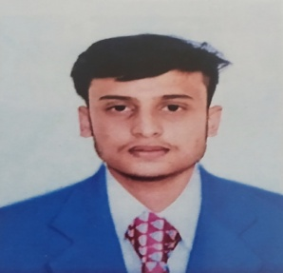

ANISH KUMAR SINGH(17BTREC017) VIJAYA KUMAR S R(17BTLEC008) AKHILESH SHINDHE (17BTLEC002) RAHUL RAO SHINDE (17BTLEC012)